Дата: 18.11.2022 Клас: 6-Б

Предмет : Англійська мова

Тема: Спортивні ігри.

Мета: формувати навички вживання нових лексичних одиниць з теми «Спорт. Види спорту ; удосконалювати навички аудіювання й усного мовлення з опорою на лексико-граматичні структури; розвивати мовну здогадку; виховувати доброзичливе ставлення до співрозмовника.

Вчитель: Глуговська Л.Г.

**Хід уроку**

***1.Greeting***

Good morning, children! How are you?

I see you are ready to begin our lesson. I hope you’ll work well and get good marks.

***2. Warming up***

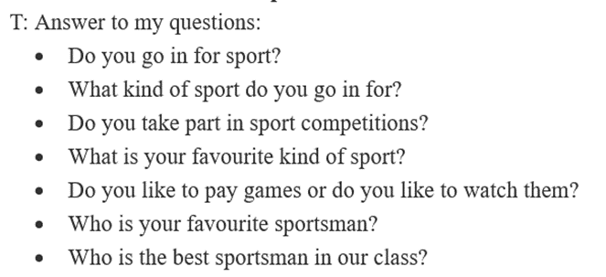

***3.Grammar***

***PLAY***

We use “play” with any competitive game. It can also be used next to sports whose name is not also the verb (e.g. play tennis).

PLAY: tennis, golf, football, basketball, chess, etc.

***GO***

We use “go” with any activities you can do alone. It is also used with sports that end in -ing (i.e. sports whose name is also the verb / gerund).

GO: swimming, cycling, dancing, surfing, sailing, etc.

***DO***

We use “do” with any sport that is more of a physical activity. It is

used for recreational activities.

DO: yoga, judo, athletics, gymnastics, etc.

***4. Checking grammar / Reading***

***Insert the right verb (use the correct tense) and connect the sport to the picture.***

***Доповніть речення потрібним дієсловом, використовуючи правило.***

Mary and John ... sailing every year. They also love to ... golf. Some-  
times their friends ask them to ... cycling, but they don’t like that. They  
prefer to ... horseback-riding. John also ... ice-hockey and Mary loves to  
... dancing. In the summer they ... swimming a lot. John and his friends  
all ... basketball, but Mary prefers to ... yoga. When she was young  
Mary ... gymnastics and John ... athletics. When it is raining Mary  
and John like to ... chess. But in winter they always ... skiing. In spring  
John likes to ... fencing and Mary likes to ... karate. Mary especially  
likes to ... aerobics to keep fit.

***5. Listening***

Прослухай та переглянь відео. Працюємо на ст. 69.

<https://www.youtube.com/watch?v=CEbbAEQ-oHE&list=PLPLUeg39dgMyCuVbVjl5haaXA04M9Yyy9&index=22>

***6. Writing***

***Friday, the eighteenth of November***

***Homework***

***Exercise 1 (с) page 69***

*Прослухавши аудіо, доповніть речення.*

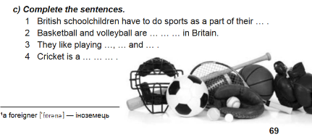

***7.Homework***

Домашнє завдання:

1. Опрацюйте конспект уроку, перегляньте відео;

3. Ex. 1 (с) page 69 - письмово.

**Надіслати виконані вправи у Вайбер (0964124047) – Людмила Григорівна або прикріпити на Human.**